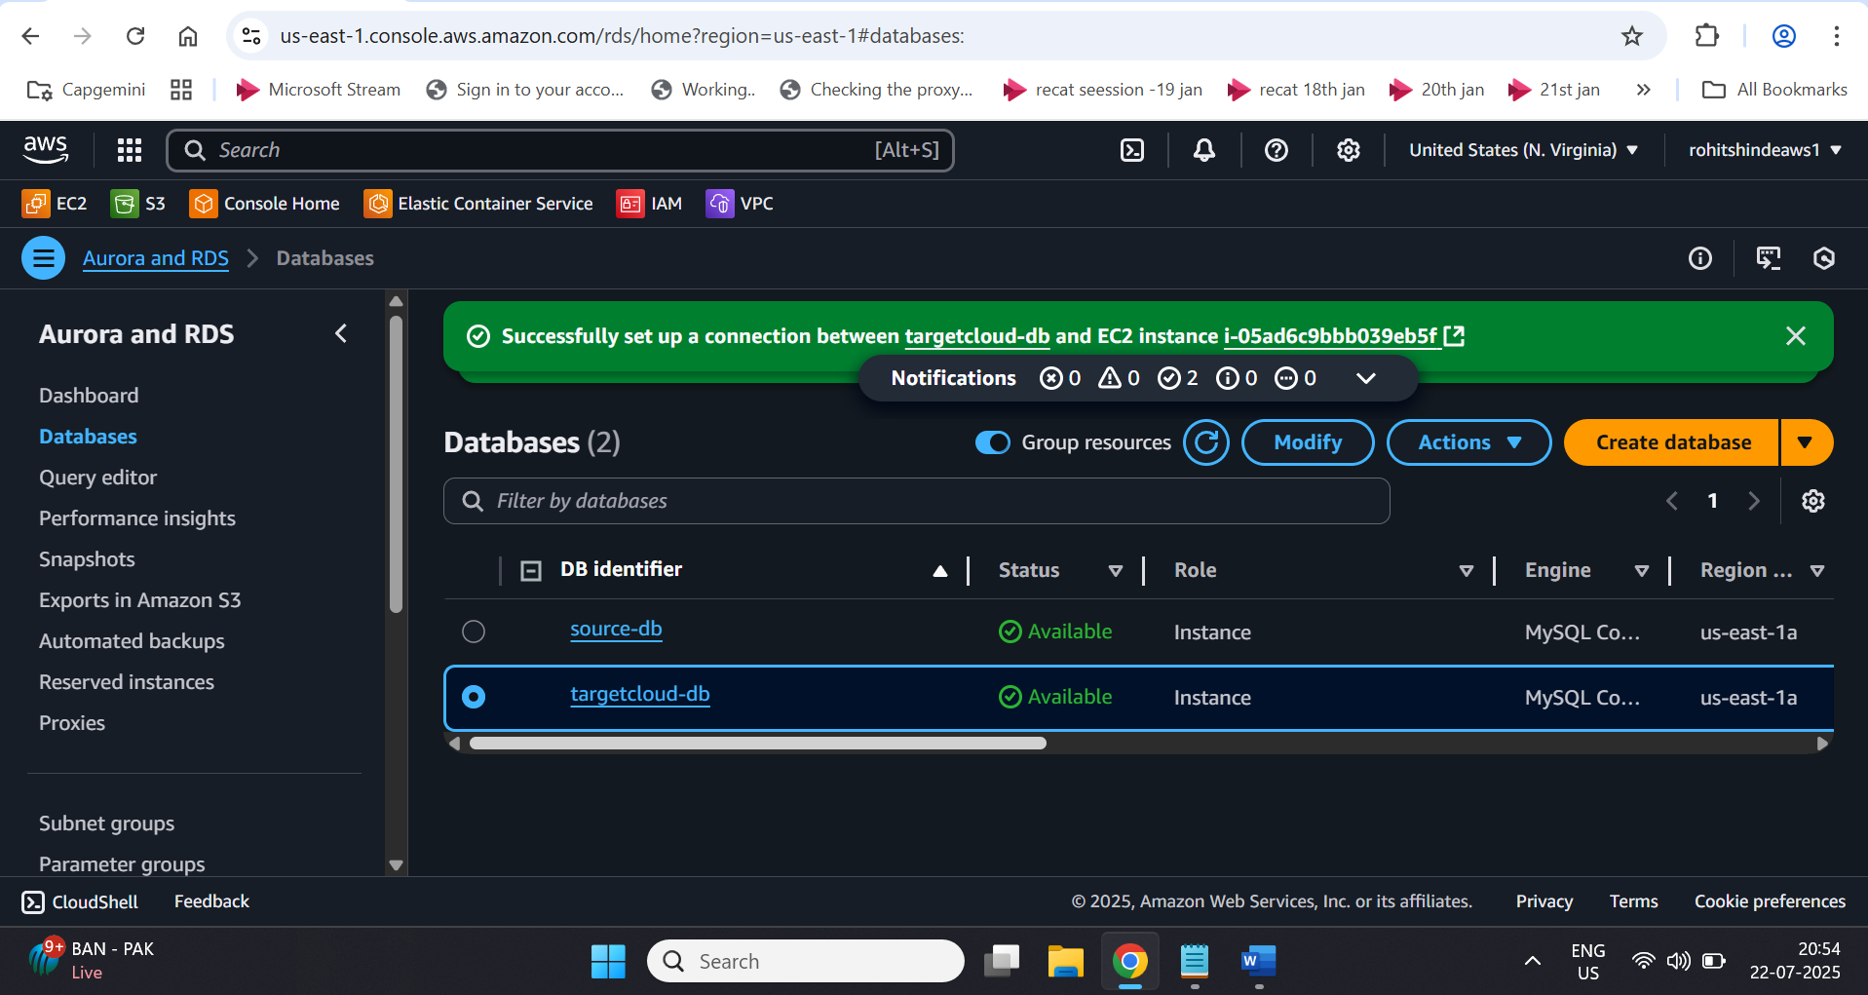

Connecting to source db having some data

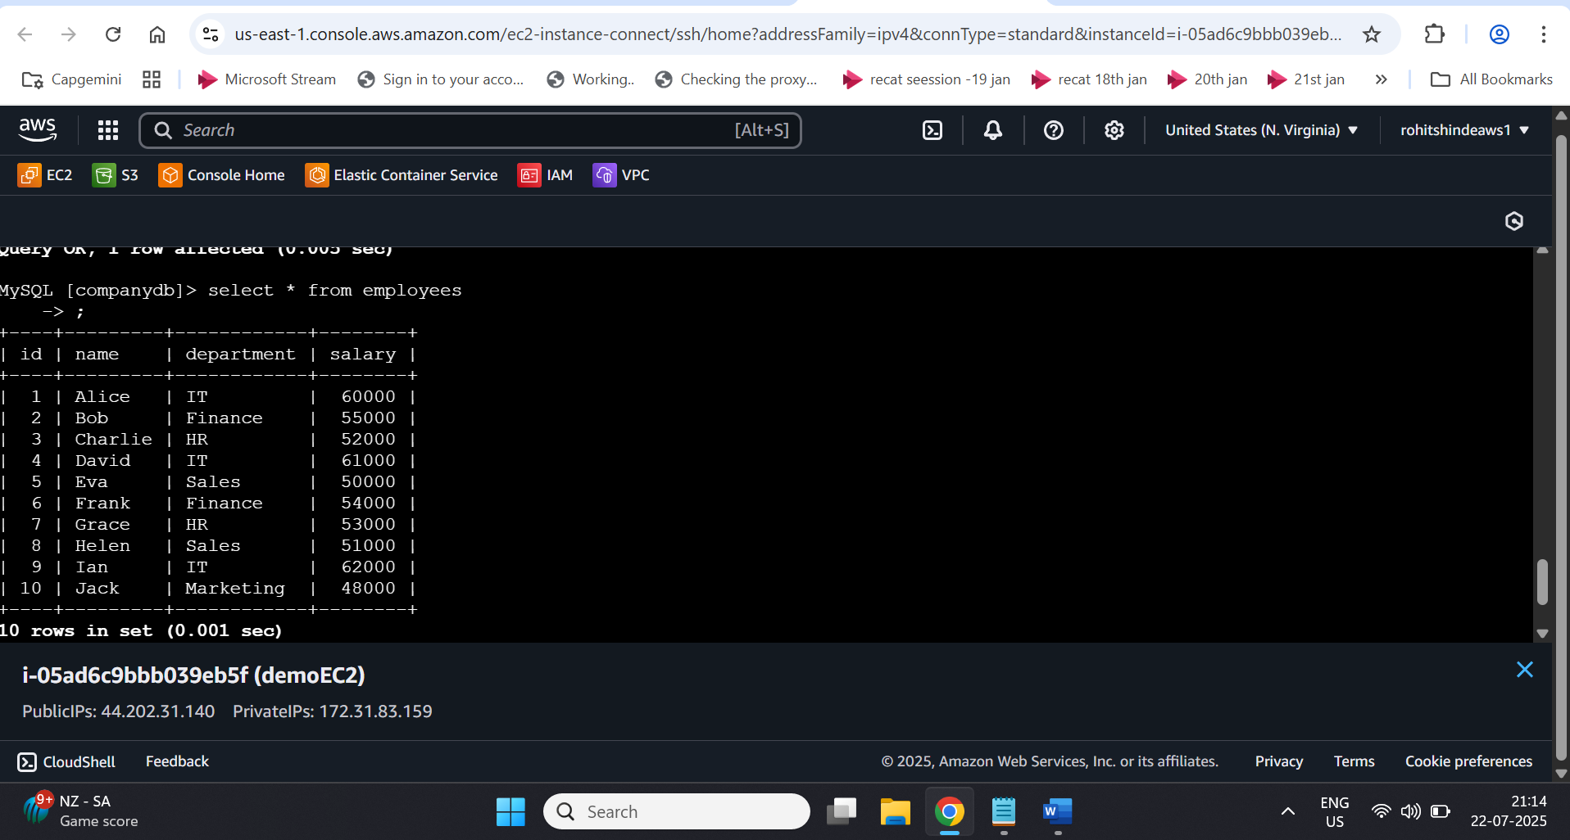

\*\*

Replication instance

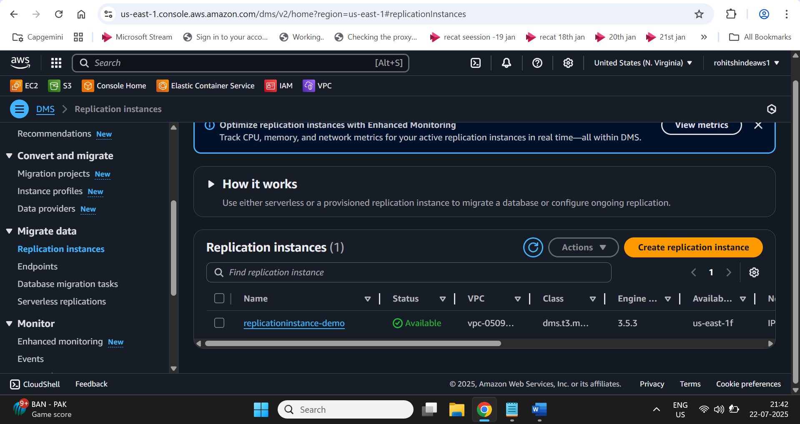

Source end point/target endpoint

Connection successful via replication instance -

Migration in progress

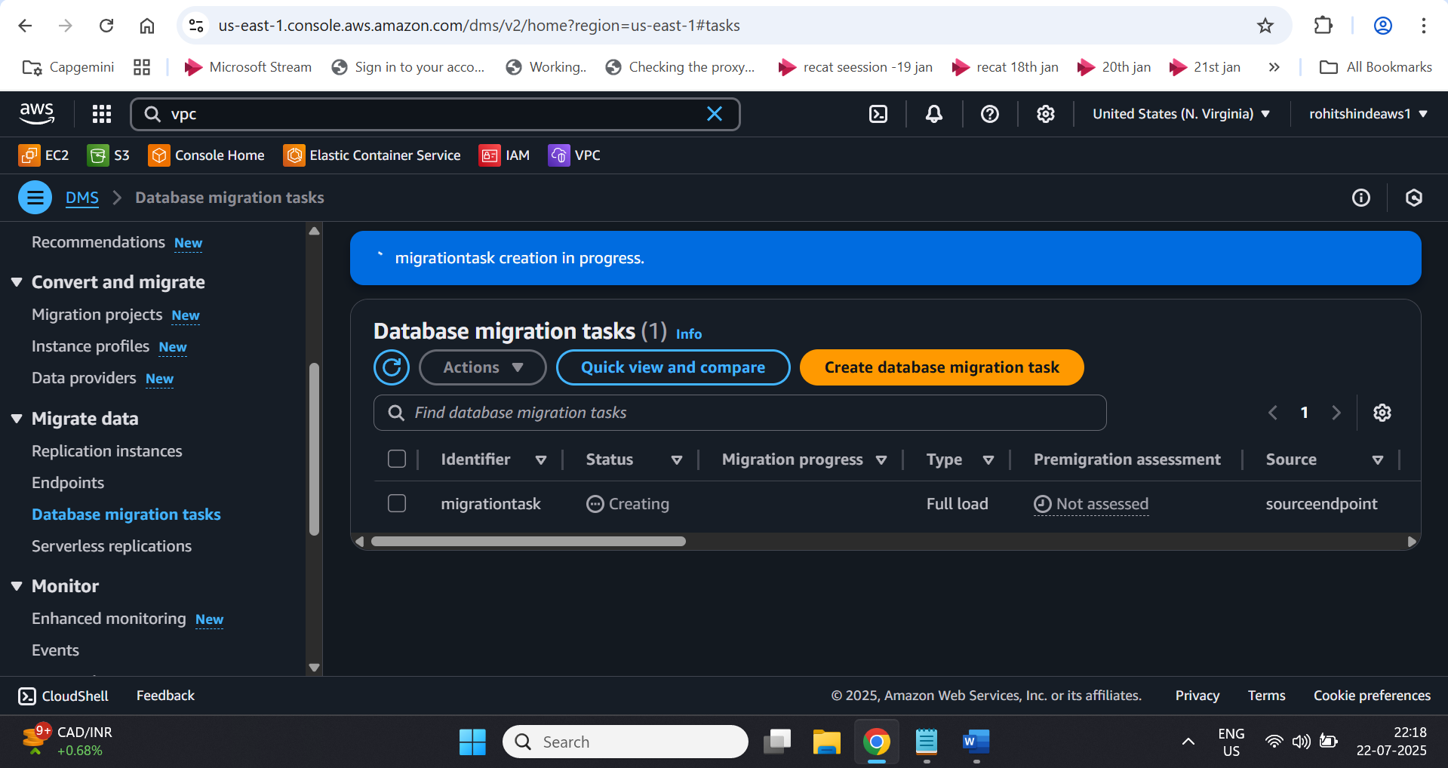

Migration complete

Connecting EC2 and reading data from targetdb



